Question 1

Given the assignment problem

$$C=\begin{matrix}Job 1 & Job 2 & Job 3 & \\ 4 & 7 & 3 & Person a \\ 2 & 6 & 1 & Person b \\ 3 & 9 & 4 & Person c\end{matrix}$$

The cost matrix C represents the assignment costs C[i, j], where persons 1, 2, and 3 are denoted as persons a, b, and c, respectively.

1. Solving the assignment problem by the greedy approaches we get:

Row-by-row:

Row 1 $→Cost =3$: Person a $→$ Job 3

Row 2 $→Cost =2$: Person b $→$ Job 1

Row 3 $→Cost =9$: Person c $→$ Job 2

The optimal solution is {a $→$ 3, b $→$ 1, c $→$ 2} with the total cost = $3+2+9 =14$ which is the minimal cost.

Column-by-Column:

Column 1 $→Cost =2 : Person b → Job 1$

Column 2 $→Cost =7 : Person a → Job 2$

Column 3 $→Cost =4 : Person c → Job 3$

The optimal solution is {a $→$ 2, b $→$ 1, c $→$ 3} with the total cost = $2+7+4 =13$ which is the minimal cost.

Entire matrix:

Choice 1 $→ Cost =1 : Person b → Job 3$

Choice 2 $→$ $Cost =3 : Person c → Job 1$

Choice 3 $→$ $Cost =7 : Person a → Job 2$

The optimal solution is {a $→$ 2, b $→3$, c $→$ 1} with the total cost = $1+3+7 =11$ which is the minimal cost.

1. Given the assignment problem

$$C=\begin{matrix}Job 1 & Job 2 & Job 3 & Job 4 & \\ 11 & 12 & 18 & 40 & Person a \\ 14 & 15 & 13 & 22 & Person b \\ 11 & 17 & 19 & 23 & Person c \\ 17 & 14 & 20 & 28 & Person d\end{matrix}$$

The cost matrix C represents the assignment costs C[i, j], where persons 1, 2, 3, and 4 are denoted as persons a, b, c, and d, respectively.

Solving the assignment problem by a branch-and-bound technique we get:

The optimal solution would have a total cost at least $lb =11+13 +11 +14=49$ this is represented at Node 0.

Level 1 consists of lower bounds for each value in row 1:

Node $1:a→1, lb =11+13+17+14= 55$

$$Node 2: a→2, lb =12+13+11+17= 53$$

$$Node 3: a→3, lb =18+14+11+14= 57$$

$$Node 4: a→4, lb =40+13+11+14=78$$

Node 2 is the most promising node since it has the lowest lower bound value.

Expanding from Node 2 we get:

Node $5:b→1, lb =12+14+19 +20 = 65$

$$Node 6: b→3, lb =12 +13 +11 +17 = 53$$

$$Node 7: b→4, lb =12 + 22+11+17= 62$$

Node 2 is the most promising node since it has the lowest lower bound value. Node 8 $:c→1\left(d→4\right),cost=12+13+11+28=64$

Node 9 $:c→4\left(d→1\right),cost=12+13+23+17=65$

The optimal solution found using promising nodes is {a $→$ 2, b $→3$, c $→$ 1, d $→$ 4} with a total cost of 64. Node 1 is expanded since it has a lower bound value lower than the solution found:

Expanding from Node 1 we get:

Node $10:b→2, lb =11+15+19+20 = 65$

$$Node 11: b→3, lb =11+13+17+14 =55$$

$$Node 12: b→4, lb =11+22+17+14=64$$

Node 2 is expanded because it is the most promising with a lower bound smaller than the previously found solution:

Node 13 $:c→2\left(d→4\right),cost=11+13+17+28=69$

Node 14 $:c→4\left(d→2\right),cost=11+13+23+14=61$

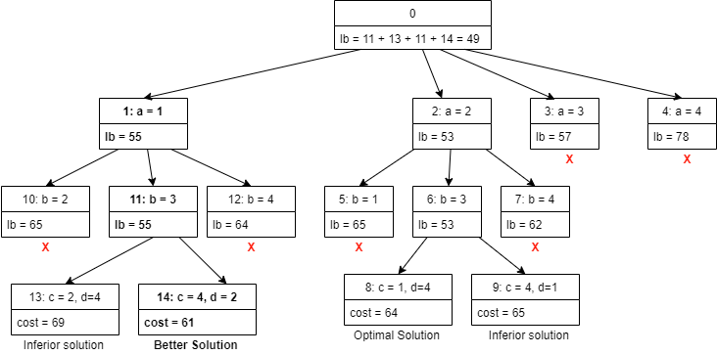

The btter optimal solution is {a $→$ 1, b $→3$, c $→$ 4, d $→$ 2} with the total cost of 61.

Question 2

1. Solve the following instance of the 0/1 knapsack problem by a greedy technique.

|  |  |  |
| --- | --- | --- |
| Item | Weight | Value |
| 1 | 1 | $1 |
| 2 | 2 | $6 |
| 3 | 5 | $18 |
| 4 | 6 | $22 |
| 5 | 7 | $28 |

W=11

The value to weight ratios are computed where $r_{i}= v_{i}/w_{i}$

|  |  |  |  |
| --- | --- | --- | --- |
| Item | Weight | Value | $$v_{i}/w_{i}$$ |
| 1 | 1 | $1 | 1 |
| 2 | 2 | $6 | 3 |
| 3 | 5 | $18 | 3.6 |
| 4 | 6 | $22 | 3.67 |
| 5 | 7 | $28 | 4 |

The items are sorted in descending order according to the ratio:

|  |  |  |  |
| --- | --- | --- | --- |
| Item | Weight | Value | $$v_{i}/w_{i}$$ |
| 5 | 7 | $28 | 4 |
| 4 | 6 | $22 | 3.67 |
| 3 | 5 | $18 | 3.6 |
| 2 | 2 | $6 | 3 |
| 1 | 1 | $1 | 1 |

Items are selected in descending order:

Select item 5, total weight = 7 < 11 $∴$ Item selected. Knapsack contents: {5}

Add item 4, total weight = 13 > 11 $∴$ Item not selected. Knapsack contents: {5}

Add item 3, total weight = 12 > 11 $∴$ Item not selected. Knapsack contents: {5}

Add item 2, total weight = 9 < 11 $∴$ Item selected. Knapsack contents: {5, 2}

Add item 1, total weight = 10 < 11 $∴$ Item selected. Knapsack contents: {5, 2, 1}

The items selected are {5, 2, 1} with a total weight of 10 and value of 28 + 6 + 1 = $35.

1. Solve the following instance of the 0/1 knapsack problem by a dynamic programming technique:

|  |  |  |
| --- | --- | --- |
| Item | Weight | Value |
| 1 | 1 | $1 |
| 2 | 2 | $6 |
| 3 | 5 | $18 |
| 4 | 6 | $22 |
| 5 | 7 | $28 |

W=11

The following recurrence relation and the weights and values given above are used to calculate the values for the DP table below:

$$F\left(i,j\right)=\left\{\begin{matrix}F\left(i-1,j\right) & if w_{i}>j \\ max\{ v_{i }+ F(i-1, j-w_{i}), F(i-1, j)\} & if w_{i }≤j\end{matrix}\right.$$

The recurrence relation above was used to create the following dynamic programming table:

|  |  |  |  |  |  |  |  |  |  |  |  |  |
| --- | --- | --- | --- | --- | --- | --- | --- | --- | --- | --- | --- | --- |
| i | 0 | 1 | 2 | 3 | 4 | 5 | 6 | 7 | 8 | 9 | 10 | 11 |
| 0 | 0 | 0 | 0 | 0 | 0 | 0 | 0 | 0 | 0 | 0 | 0 | 0 |
| 1 | 0 | 1 | 1 | 1 | 1 | 1 | 1 | 1 | 1 | 1 | 1 | 1 |
| 2 | 0 | 1 | 6 | 7 | 7 | 7 | 7 | 7 | 7 | 7 | 7 | 7 |
| 3 | 0 | 1 | 6 | 7 | 7 | 18 | 19 | 24 | 25 | 25 | 25 | 25 |
| 4 | 0 | 1 | 6 | 7 | 7 | 18 | 22 | 24 | 28 | 29 | 29 | 40 |
| 5 | 0 | 1 | 6 | 7 | 7 | 18 | 22 | 28 | 29 | 34 | 35 | 40 |

The maximal value is F (5,11) = $40.

Using the backtracking algorithm, and the Dynamic programming table above (F):

$F\left(5,11\right)=40 = F\left(4,11\right)=40$ move to F(4,11) $$F\left(4,11\right)= 40>F\left(3,11\right)= 25∴item 4 selected$$  $Capacity = 11 -6=5,$ move to F(3, 5) $$F\left(3,5\right)=18>F\left(2,5\right)=7∴item 3 selected$$ $Capacity = 5 - 5 = 0$, move to F(2,0) $F\left(2,0\right)=0=F\left(1,0\right)=0,$ move to F(1,0) $F\left(1,0\right)=0 =F\left(0,0\right)=0,$ Algorithm terminated.

The value of the optimal solution is $40, selected items are {4,3}, the total weight is 11.

Question 3

1. Solve the all-pairs shortest-path problem by Floyd’s algorithm for the weight matrix given.

$$W=\begin{matrix}0 & 5 & ∞ & ∞ \\ 50 & 0 & 15 & 5 \\ 30 & ∞ & 0 & 15 \\ 15 & ∞ & 5 & 0\end{matrix}$$

We let the row and columns of the matrix represent origins and destinations with labels as follows:

$$D^{(0)}=\begin{matrix} & a & b & c & d \\ a & 0 & 5 & ∞ & ∞ \\ b & 50 & 0 & 15 & 5 \\ c & 30 & ∞ & 0 & 15 \\ d & 15 & ∞ & 5 & 0\end{matrix}$$

For paths through **a**:

$${d_{cb}}^{(1)}= min\{{d_{cb}}^{(0)}, {d_{ca}}^{(0)}+{d_{ab}}^{(0)}\} = min\{∞, 30+5\} = 35$$

$${d_{db}}^{(1)}= min\{{d_{db}}^{(0)}, {d_{da}}^{(0)}+{d_{ab}}^{(0)}\} = min\{∞, 15+5\} = 20$$

$$D^{(1)}=\begin{matrix} & a & b & c & d \\ a & 0 & 5 & ∞ & ∞ \\ b & 50 & 0 & 15 & 5 \\ c & 30 & 35 & 0 & 15 \\ d & 15 & 20 & 5 & 0\end{matrix}$$

For paths through **b**:

$${d_{ac}}^{(2)}= min\{{d_{ac}}^{(1)}, {d_{ab}}^{(1)}+{d_{bc}}^{(1)}\} = min\{∞, 5+15\} = 20$$

$${d_{ad}}^{(2)}= min\{{d_{ad}}^{(1)}, {d_{ab}}^{(1)}+{d_{bd}}^{(1)}\} = min\{∞, 5+5\} = 10$$

$$D^{(2)}=\begin{matrix} & a & b & c & d \\ a & 0 & 5 & 20 & 10 \\ b & 50 & 0 & 15 & 5 \\ c & 30 & 35 & 0 & 15 \\ d & 15 & 20 & 5 & 0\end{matrix}$$

For paths through **c**:

$${d_{ba}}^{(3)}= min\{{d_{ba}}^{(2)}, {d_{bc}}^{(2)}+{d_{ca}}^{(2)}\} = min\{50, 15+30\} = 45$$

$${d_{bd}}^{\left(3\right)}= min\{{d_{bd}}^{(2)}, {d_{bc}}^{(2)}+{d_{cd}}^{(2)}\} = min\{5, 15+15\} = 5$$

$${d_{da}}^{(3)}= min\{{d_{da}}^{(2)}, {d_{dc}}^{(2)}+{d_{ca}}^{(2)}\} = min\{15, 5+30\} = 15$$

$$D^{(3)}=\begin{matrix} & a & b & c & d \\ a & 0 & 5 & 20 & 10 \\ b & 45 & 0 & 15 & 5 \\ c & 30 & 35 & 0 & 15 \\ d & 15 & 20 & 5 & 0\end{matrix}$$

For paths through **d**:

$${d_{ac}}^{(4)}= min\{{d_{ac}}^{(3)}, {d_{ad}}^{(3)}+{d_{dc}}^{(3)}\} = min\{30, 10+5\} = 15$$

$${d_{ca}}^{(4)}= min\{{d_{ca}}^{(3)}, {d_{cd}}^{(3)}+{d_{da}}^{(3)}\} = min\{30, 30+30\} = 30$$

$${d_{ba}}^{\left(4\right)}= min\{{d_{ba}}^{(3)}, {d_{bd}}^{(3)}+{d_{da}}^{(3)}\} = min\{45, 5+15\} = 20$$

$${d_{bc}}^{(4)}= min\{{d_{bd}}^{(3)}, {d_{bd}}^{(3)}+{d_{dc}}^{(3)}\} = min\{15, 5+5\} = 10$$

$$D^{(4)}=\begin{matrix} & a & b & c & d \\ a & 0 & 5 & 15 & 10 \\ b & 20 & 0 & 10 & 5 \\ c & 30 & 35 & 0 & 15 \\ d & 15 & 20 & 5 & 0\end{matrix}$$

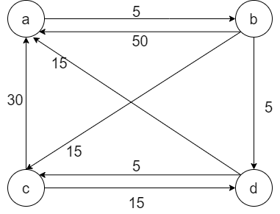

Question 4

1. The instance of the subset problem $S= \{1,2,5,6,8\}$ and $d=9$ can be solved by the backtracking technique as follows:

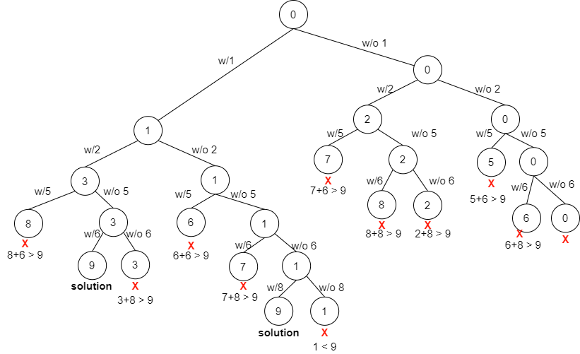

Solution 1 = {1,2,6}

Solution 2 = {1,8}

Question 5

1. Solve the following instance of the 0/1 knapsack problem by a branch and bound technique.

|  |  |  |
| --- | --- | --- |
| Item | Weight | Value |
| 1 | 10 | $100 |
| 2 | 7 | $63 |
| 3 | 8 | $56 |
| 4 | 4 | $12 |

W=16

The value to weight ratios are computed where $r_{i}= v_{i}/w_{i}$

|  |  |  |  |
| --- | --- | --- | --- |
| Item | Weight | Value | $$r_{i}=v_{i}/w_{i}$$ |
| 1 | 10 | $100 | 10 |
| 2 | 7 | $63 | 9 |
| 3 | 8 | $56 | 7 |
| 4 | 4 | $12 | 3 |

The items are already sorted in descending order according to the ratio.

The upper bound $ub = v + (W-w)(v_{i+1}/w_{i+1})=0+(16-0) (10)=160$

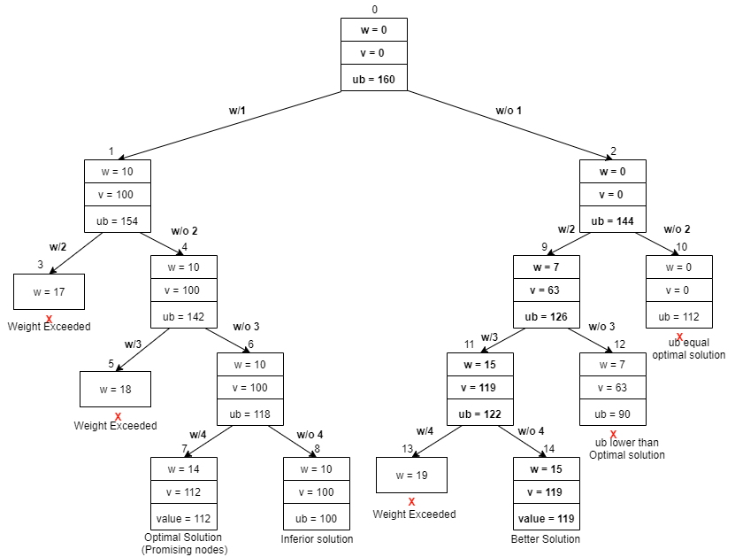

From node 0:

Node 0 $\left(w=0,v=0\right):ub=0+\left(16-0\right)\left(10\right)=160$ Node 1 $\left(w=10,v=100\right):ub=100+\left(16-10\right)\left(9\right)=154$ Node 2 $(w=0, v=0): ub = 0+(16-0) (9)=144$

Expanding from Node 1:

Node 3 $(w=17)$ Weight exceeded.  
Node 4 $(w=10, v=100): ub =100+(16-10) (7)=142$

From Node 4:

Node 5 $(w=18)$ Weight exceeded.  
Node 6 $(w=10, v=100): ub =100+(16-10) (3)=118$

From Node 6:

Node 7 $(w=14, v=112): ub =112+(16-14) (0)=112$ (optimal solution)   
Node 8 $(w=10, v=100): ub =100+(16-10) (0)=100$

The value of the optimal solution using only promising nodes is $112, selected items are {1,4}, the total weight is 14.

Expanding from Node 2:

Node 9 $\left(w=7,v=63\right):ub=63+\left(16-7\right)\left(7\right)=126$ Node 10 $(w=0, v=0): ub = 0+(16-0) (7)=112$

From Node 9: (Since the ub is higher than the optimal solution)

Node 11 $\left(w=15,v=119\right):ub=119+\left(16-15\right)\left(3\right)=122$ Node 12 $(w=7, v=63): ub = 63+(16-7) (3)=90$ (lower than optimal solution)

From Node 11: (Since the ub is higher than the optimal solution)

Node 13 $(w=19)$ Weight exceeded.  
Node 8 $(w=15, v=119): ub =119+(16-15) (0)=119$ (better solution)

The value of the better optimal solution is $119, selected items are {2,3}, the total weight is 15.

1. def changeMaking(D, n):  
    # changeMaking algorithm adapted from the Dynamic Programming lecture  
    F = [0 for i in range(n+1)] # Creates the array to establish it's length  
    m = len(D)  
    for i in range(1, n+1):  
    temp = float('inf')  
    j = 1  
    while j <= m-1 and D[j] <= i:  
    temp = min(F[i - D[j]], temp)  
    j += 1  
    F[i] = temp +1  
    print("The minimum number of coins to make change for n = ", n, " is ", F[n])  
    return F[n], F # returns F instead of using a global variable  
     
     
   def Backtrack(D, n, minimum, F):  
    s = [] # stores the minimum coin set as it is generated  
    j = len(D)-1  
    while j >= 1 and n > 0:  
    # checking the computations for their component denominations  
    if F[n-D[j]] + 1 == minimum and D[j] <= n:  
    s.append(D[j])  
    n = n - D[j]   
    if n > 0:  
    j = len(D) - 1 # reset the pointer to the denominations array   
    minimum = F[n] # move to the next minimum produced  
    else:  
    j = 0  
    else:  
    j -= 1  
    return s  
     
     
   D = [0, 1, 5, 10]  
   n = 8  
   minm, F = changeMaking(D, n)  
   min_coin_set = Backtrack(D, n, minm, F)  
   print("The minimum coin set for n = ", n, "is", min_coin_set)